**Lakhpreet Singh**

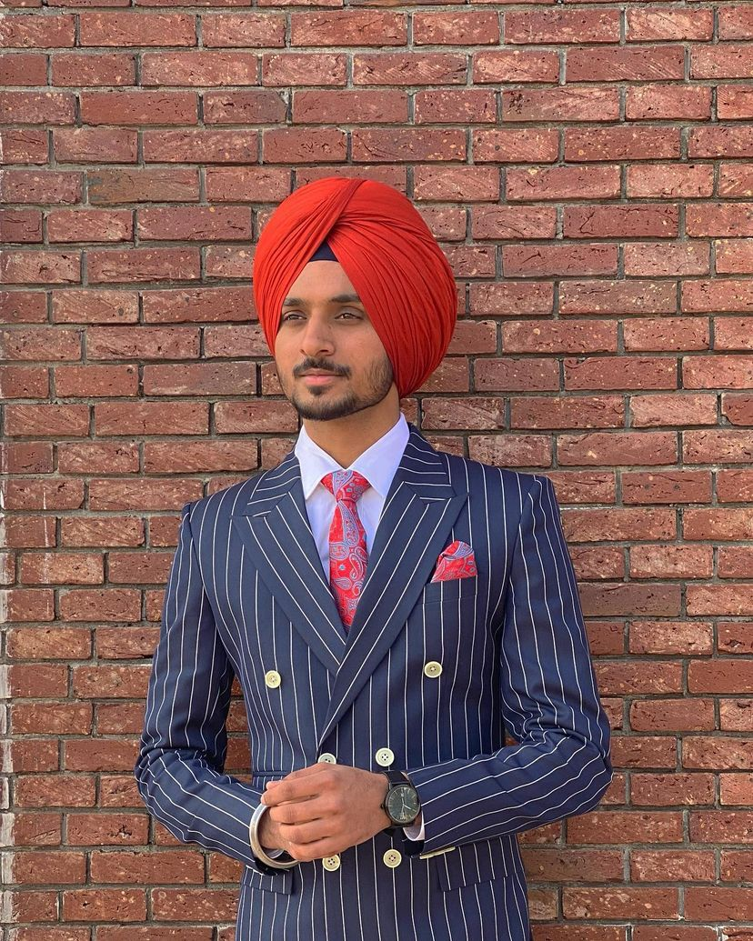

Web designer

+1 2897885911 sardarlakhpreet@gmail.com



|  |  |
| --- | --- |
| **WORK EXPERIENCE**  Fresher  **AGE** 21 | **ABOUT ME**  Seeking a career that is challenging and interesting, and lets me work on the leading areas of sites and creations of that gives me opportunities to learn, innovate and enhance my skills and strengths in conjunction with company goals and objectives.  **Education** |
| **Web designing course**  CDI college, Montreal  Quebec  **Senior Secondary**  Public Khalsa Sen. Sec. School  Bhogpur  PSEB Board    **Matriculation**  Public Khalsa Sen. Sec. School  Bhogpur  PSEB Board | Pursuing (2020-2022)    Passed, June 2018    Passed, may 2016  Marks 92%  **Skills** |

* Web designing
* Photoshop
* Wordpress site creations



**Computer Proficiency**

MS

Office,

language

•

English

.

Hindi, Punjabi

web

designing

Research

work

Structure Analysis



**Languages**



**Personal Interests**



**Personal Details**

Father’s Name: Jaswant singh Marital Status: Single

Birthday: 16 jaunary, 2001 Nationality: Indian

# Declaration

I, Lakhpreet Singh, hereby declare that the information contained herein is true and correct to the best of my knowledge and belief.

lakhpreet Singh Bhogpur, Punjab